Two-Way Mixed Model ANOVA (BW)
Amyah Espanol - APM1111 Statistical Theory
Colab Python Code & Files
https://colab.research.google.com/drive/1GOHdHdDygwmFpCEHBkin_usSBerwFAOC?usp=sharing
https://github.com/amyahespanol/Amyah-Espanol-Statistical-Theory-APM1111
Introduction
A two-way mixed ANOVA was conducted to examine the effects of Margarine Brand (factors: Brand A vs. Brand B) and Time (factors: Before, After 4 weeks, and After 8 weeks) on cholesterol levels. The primary goal was to determine if the change in cholesterol over time depends on the brand of margarine used and eaten.
Assumptions
- Assumption #1: You have a continuous dependent variable.
- Assumption #2: You have one between-subjects factor (i.e., independent variable) that is categorical with two or more categories.
- Assumption #3: You have one within-subjects factor (i.e., independent variable) that is categorical with two or more categories.
- Assumption #4: There should be no significant outliers in any cell of the design.
- Assumption #5: The dependent variable should be approximately normally distributed for each cell of the design.
- Assumption #6: The variance of your dependent variable should be equal between the groups of the between-subjects factor, referred to as the assumption of homogeneity of variances.
- Assumption #7: There should be homogeneity of covariances.
- Assumption #8: The variance of the differences between groups should be equal, referred to as the assumption of sphericity.
Null and alternative hypotheses
The null hypothesis for the main effects of a BW ANOVA is:
Main Effect of Time:
H0: There is no significant difference in mean cholesterol levels across the three time points (μBefore = μ4weeks = μ8weeks).
HA: At least one time point mean is significantly different from the others.
Main Effect of Margarine Brand:
H0: There is no significant difference in mean cholesterol levels between the two brands of margarine (μBrand A = μBrand B)
HA: There is a significant difference in mean cholesterol levels between Brand A and Brand B.
The null hypothesis for the interaction effect (margarine and time) of a 2B ANOVA is:
H0: There is no significant difference in the cholesterol levels between the two brands of margarine over the time points.
HA: There is a significant interaction effect. The change in cholesterol levels over time is different depending on the brand of margarine used.
Dataset and Problem
A study was done to determine the effectiveness of two different brands of margarine (Brand A and Brand B) in reducing cholesterol levels over different periods of time. The researcher used 18 participants (ID 1–18) and measured their cholesterol levels at three time points (before starting the diet, after 4 weeks, and after 8 weeks). The goal of the analysis is to find if cholesterol reduction is dependent on the brand of margarine consumed, the time of the diet, or the interaction of both.

Checking of Assumptions
- Assumption #1: You have a continuous dependent variable.
Remark. The dependent variable is cholesterol level. The values in the dataset are numerical and use a continuous measurement.
- Assumption #2: You have one between-subjects factor (i.e., independent variable) that is categorical with two or more categories.
Remark. The between-subjects factor is Margarine Brand. This is a categorical variable made of two independent groups: Brand A and Brand B.
- Assumption #3: You have one within-subjects factor (i.e., independent variable) that is categorical with two or more categories.
Remark. The within-subjects factor is Time. This is a categorical factor made of three categories where the same participants were measured at intervals: Before, After 4 weeks, and After 8 weeks.
- Assumption #4: There should be no significant outliers in any cell of the design.
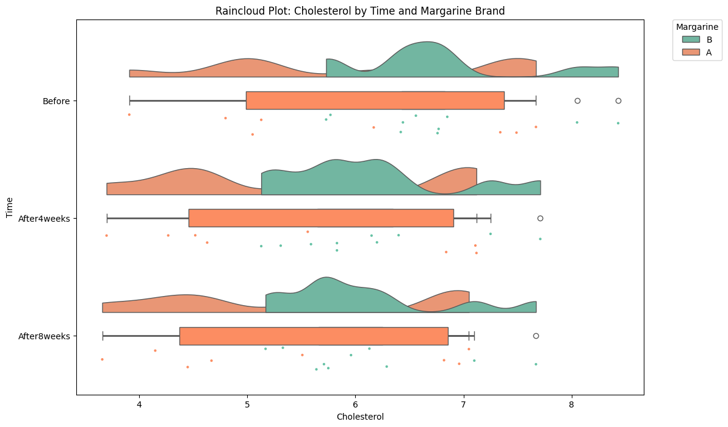
Remark. There were no significant outliers using visual inspection of the Raincloud plot. Some points kind of appear at the upper edge of the distribution across time points, but they aren’t extreme enough to be excluded from the analysis.

- Assumption #5: The dependent variable should be approximately normally distributed for each cell of the design.
Remark. Cholesterol levels were approximately normally distributed for each cell of the design, using the Shapiro-Wilk test and skewness and kurtosis values. Shown in the tables below, the p-values for all combinations of Margarine Brand and Time were greater than .05 (134 - .400). This shows that the assumption of normality was met for all groups.
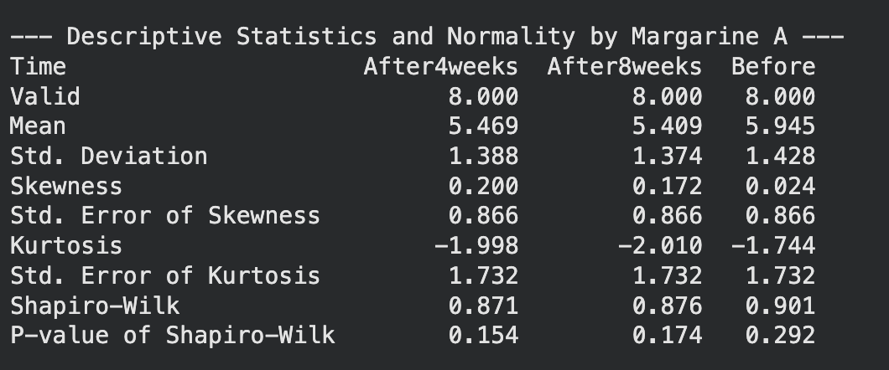
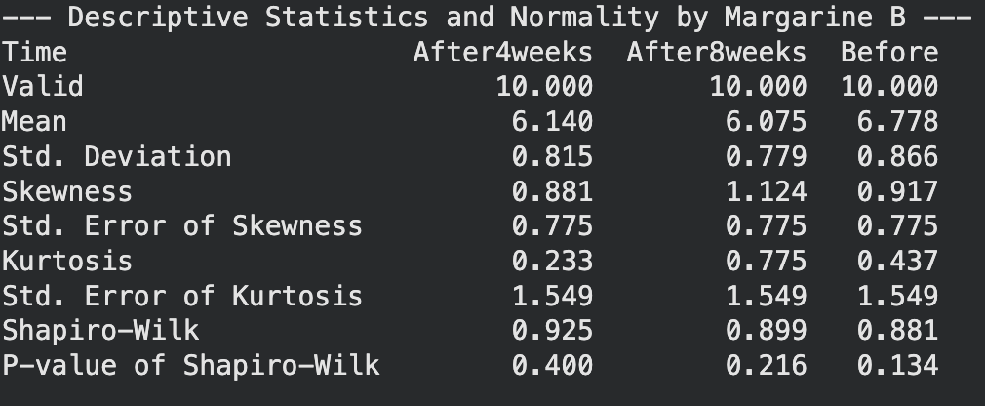

- Assumption #6: The variance of your dependent variable should be equal between the groups of the between-subjects factor, referred to as the assumption of homogeneity of variances.
Remark. There was homogeneity of variances for the cholesterol levels between the two margarine brands at the "Before" (p = .052) and "After 4 weeks" (p = .058) time points, using Levene’s test of equality of variances. The "After 8 weeks" time point showed a p-value slightly below the boundary (p = .045). The mixed ANOVA doesn’t fail with small violations of this assumption when group sizes are relatively equal. Therefore, the assumption of homogeneity of variances was still met.
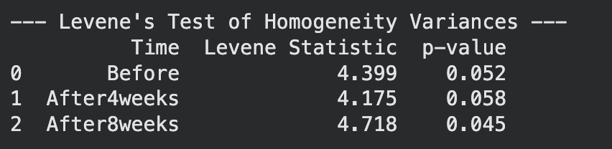
- Assumption #7: There should be homogeneity of covariances.
Remark. There was homogeneity of covariances using the Box’s M test (p = .670). Since the p-value is much greater than the alpha level of .001, the assumption of equal covariance matrices is met. This shows that the relationship between the repeated measurements of cholesterol is consistent across both margarine brands.


- Assumption #8: The variance of the differences between groups should be equal, referred to as the assumption of sphericity.
Remark. Mauchly’s test shows that the assumption of sphericity had been violated (W = 0.381, p < .001). Because the p-value is less than .05, we can’t assume sphericity. We must use a Greenhouse-Geisser correction (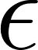 = 0.618) to be applied to the within-subjects tests to adjust the degrees of freedom.
Computation:
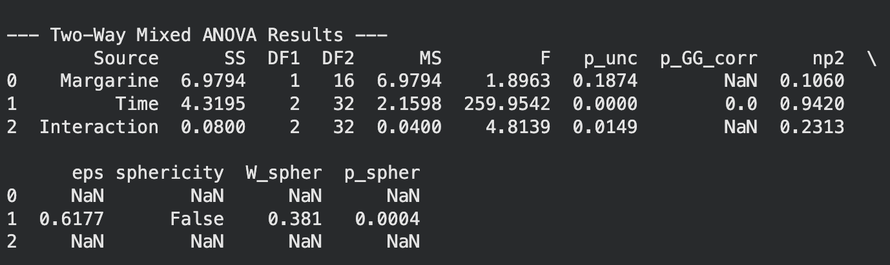
Remark. Using Mixed ANOVA, there was a significant main effect for Time, F(1.23, 19.78) = 259.95, p < .001, and a significant Brand and Time interaction, F(1.23, 19.78) = 4.81, p = .0149 (0.033 - Greenhouse-Geisser adjusted), η²p = .231. The main effect of Brand wasn’t significant, F(1, 16) = 1.90, p = .187. Since the interaction is significant, we should proceed to analyze the simple main effects.

Results of Simple Main Effects
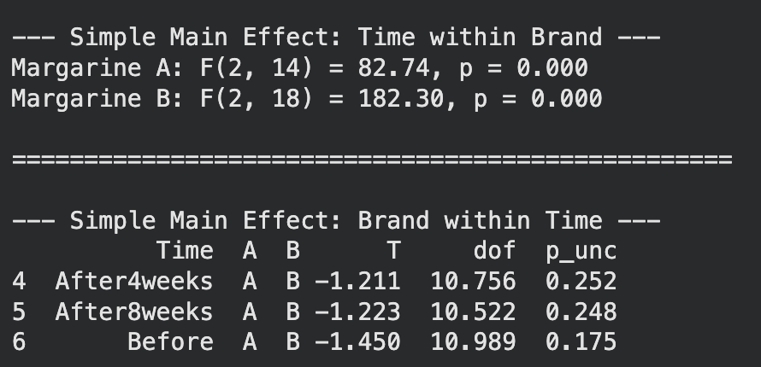
Remark. The simple main effects showed that cholesterol levels changed significantly over time for both Brand A, F(2, 14) = 82.74, p < .001, and Brand B, F(2, 18) = 182.30, p < .001. However, there weren’t any significant differences between the two brands at the “Before” stage (p = .175), at 4 weeks (p = .252), or at 8 weeks (p = .248).
Post-Hoc Comparisons - Time
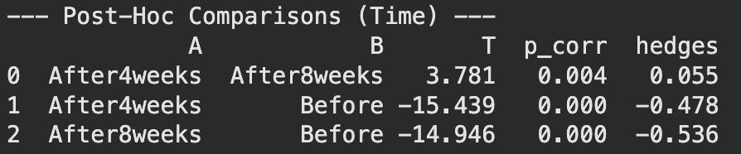
Remark. Pairwise comparisons with a Bonferroni correction showed that for both brands, cholesterol levels at 4 weeks and 8 weeks were significantly lower than the “Before” levels (p < .001). For Brand B, the change from 4 weeks to 8 weeks was also significant (p = .033). For Brand A, the change between 4 and 8 weeks didn’t reach significance (p = .069).

APA Report Summary
A two-way mixed ANOVA was done to determine the effectiveness of two margarine brands (Brand A and Brand B) on cholesterol levels over three time points (Before, After 4 weeks, and After 8 weeks). Residual analysis was done to test the assumptions of the mixed ANOVA. Outliers were seen by inspection of a raincloud plot, and normality was tested using Shapiro-Wilk’s normality test for each cell of the design. Homogeneity of variances was tested by Levene’s test, and homogeneity of covariances was tested by Box’s M test. There were no significant outliers, and the data was normally distributed (p > .05). The homogeneity of variances (p > .05) and covariances (p = .670) were met. However, Mauchly’s test of sphericity showed that the assumption of sphericity was violated for the within-subjects factor of Time (W = 0.381, p < .001), so the degrees of freedom were corrected using Greenhouse-Geisser ( = 0.618).
There was a significant interaction between margarine brand and time on cholesterol levels, F(1.23, 19.78) = 4.81, p = .033, η²p = .231. Because the interaction was significant, there was an analysis of simple main effects. The simple main effect of Brand was analyzed at each time point with a Bonferroni-adjusted significance level of p < .016. There were no differences in mean cholesterol levels between Brand A and Brand B at the "Before" stage (p = .175), at 4 weeks (p = .252), or at 8 weeks (p = .248).
Also, the simple main effect of Time for each brand was analyzed. There was a significant difference in mean cholesterol levels over time for both Brand A, F(2, 14) = 82.74, p < .001, and Brand B, F(2, 18) = 182.30, p < .001. These were significant, so all pairwise comparisons were run for time.
For Brand A, cholesterol levels decreased significantly from "Before" (5.95 ± 1.29) to 4 weeks (5.47 ± 1.19), p < .001. However, the decrease from 4 weeks to 8 weeks (5.41 ± 1.20) wasn’t statistically significant (p = .069). For Brand B, cholesterol levels decreased at every interval. "Before" (6.78 ± 1.10) to "After 4 weeks" (6.14 ± 1.05), p < .001. The decrease was more from 4 weeks to 8 weeks (6.08 ± 1.07), p = .033.

